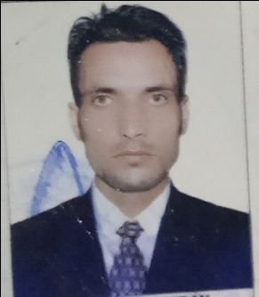 ***Name:- Hilal Ahmad Banday***

***Address:- Ward No. 1 Beerwah Budgam-JK-193411***

***Email id:-*** [***bndyhilal@gmail.com***](mailto:bndyhilal@gmail.com)

***Cell No:- +919906004788***

**Career Objective**

To work in a firm with a professional work driven environment where I can utilize and apply my knowledge , skills which would enable me a fresh graduate to grow while fulfilling organizational goals.

**Educational Qualifications**

* Bachelor’s of Computer applications (BCA) from Mohan Lal Sukhidia University Udaipur Rajasthan in 2016 with 64%
* Intermediate from Government Boys Higher Secondary School Beerwah Budgam in 2011 with 54%
* Matriculation from Mazhar Ul Haq High School Beerwah Budgam in 2009 with 60%

**Key Skills**

* Excellent Knowledge of Microsoft word related concept
* Knowledge in preparing accounting- related documents like, invoice bills, purchases, account payable and account receivable etc.
* Knowledge in Tally and Ms Excel
* Ability to prepare journals and vouchers
* Good communication skills to coordinate with vendors and auditors.
* Ability to work in a team

**Personal Detail:-**

* Fathers Name:- Mohd Assadullah banday
* Permanent Address:- Ward No 01 Beerwah Budgam J&K -193411
* Date of Birth:- 09-12-1994
* Language Known:- English, Urdu, Hindi and Kashmiri
* Martial statues:-Single
* Nationality:- Indian
* Religion:- Islam
* Hobbies:- Internet Browsing, cricket and reading

**Experiences**

5 years experience in Bajaj Automobiles

Declaration:-

I hear by declares that all the information provided above is true vto the best of my knowledge and understanding

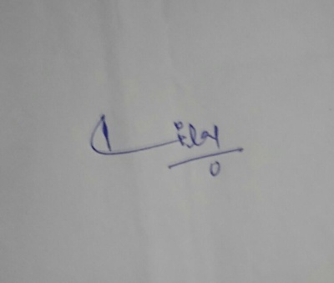

Place:- Beerwah Signature:-