**Name:** Pratik Dilip Meher

**Contact no.:** 9423809428/9356997453

**Email ID:** [meher.pratik28@gmail.com](mailto:meher.pratik28@gmail.com)

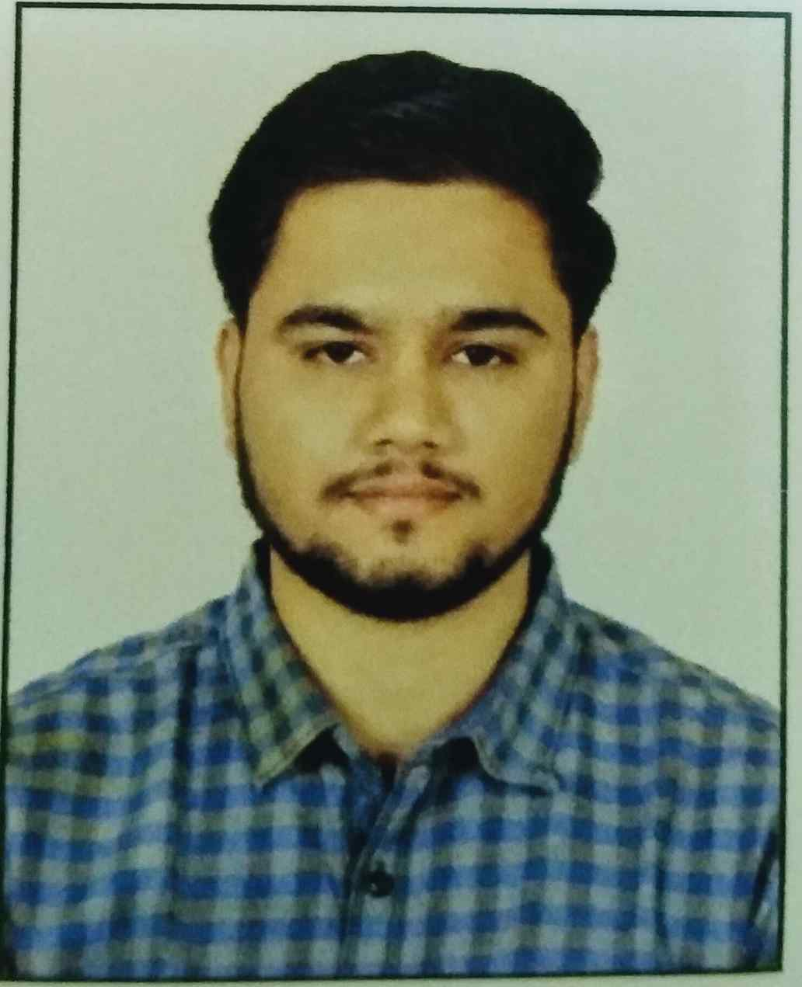

**1. OBJECTIVE**

Seeking a challenging work environment, which can help me enhance my skills and provide me ample opportunities to show my abilities, skills, and incorporate my knowledge to the best of use for Finance Industry.

**2. EDUCATIONAL QUALIFICATIONS**

|  |  |  |  |
| --- | --- | --- | --- |
| **Degree** | **Institute – University / State Board** | **Year of passing** | **Percentage (%)** |
| **M.B.A(BFSI)** | Bennett University | Pursuing | 6.5cgpa |
| **B.B.A (Finance)** | Savitribai Phule Pune University | 2019 | 53.41% |
| **H.S.C** | State Board | 2014 | 60.77% |
| **S.S.C** | State Board | 2012 | 78.91% |

**3. Certification**

|  |  |  |  |
| --- | --- | --- | --- |
| **Certification Name** | **Affiliation** | **Date of Passing/Certified** | **Expire Date**  **(If any)** |
| **TALLY ERP 9** | NATIONAL INSTITUTE OF ELECTRONICS & IT. | 28/09/2017 | PRESENT |
| **SHARE MARKET TRAINING** | WEALTH NOTE INVESTMENT ACADEMY. | 02/05/2019 | PRESENT |
| **VII - SORM** | NISM | 07/06/2021 | 02/06/2024 |
| **VA – MUTUAL FUND DISTRIBUTOR** | NISM | 16/12/2021 | 11/12/2024 |

**5. PROJECTS UNDERTAKEN (During Academics) –**

**5.1 (A) Project Title:** IMPACT OF RURAL BANKING ON FARMER

**5.2 Duration (in months):** 3 Months.

**5.3 Team Size:** Team contributor

**5.4 Accountabilities / Learnings:**

* Study about the impacts of the rural banking in the lives of the rural farmers.
* Study about the various products, on offer by the rural banks.

* Study about the efficiency of rural banking services.

**5.1(B) Project Title:** STRESS MANAGEMENT BY BANKING PROFESSIONAL

**5.2 Duration (in months):** 3 Months.

**5.3 Team Size:** Team contributor

**5.4 Accountabilities / Learnings:**

* Study the existence of stress among the employee.
* Identify factors of stress among the employee.
* Study the effect of stress on performance of employee.

**5.1 (C) Project Title:** AWARENESS AND IMPACT OF PRADHANMANTRI JAN DHAN

YOJANA.

**5.2 Duration (in months):** 3 Months**.**

**5.3 Team Size:** Team contributor

**5.4 Accountabilities / Learnings:**

* Learn about implication and effectiveness of PMJDY.
* Study the current status of PMJDY.
* Know how people aware about the PMJDY scheme.

**6. KEY SKILLS AND COMPETENCIES –**

* Finding problems and providing correct solutions.
* Ability to work as team member.
* Ability to evaluate any financial statement as well as economic situations.
* Adaptability and ability to work under pressure.
* Knowledge about technical analysis.

**7. ACHIEVEMENTS -**

* School house captain ( 2009-2011)
* Active participation in cricket, swimming at school level.
* Participated and winner of quiz competition at college level.

**8. INTEREST AND HOBBIES –**

* Playing cricket.
* Listening music.
* Exploring new places.

**9. PERSONAL DETAILS**

**9.1 Father Name:** Mr. Dilip F. Meher

**9.2 Mother Name:** Mrs. Vaishali D. Meher

**9.3 Date of Birth:** 28/04/1996

**9.4 Nationality:** Indian

**9.5 Gender:** Male

**9.6 Marital Status:** Single

**9.7 Languages Known:** English, Hindi and Marathi

**9.8 Permanent address:** Saianand, Iwale Mala, Sarasnagar, Ahmednagar. 414001

I, hereby, declare that all the information given is true to the best of my knowledge.



Date: _________________________

Place: Ahmednagar PRATIK D. MEHER